**Google Kubernetes Engine Qwik Start**

R10725012 呂晟維

<https://cloud.google.com/kubernetes-engine/docs/deploy-app-cluster>

Task 1~3 : create GKE cluster and deploy a hello-app service.

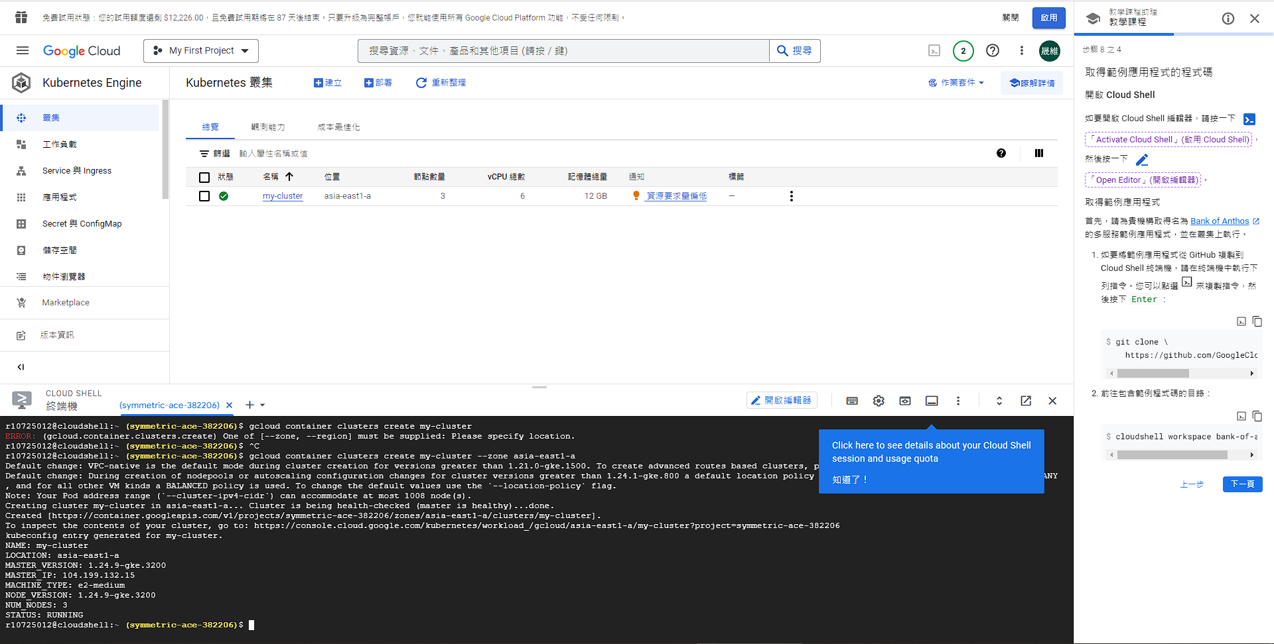

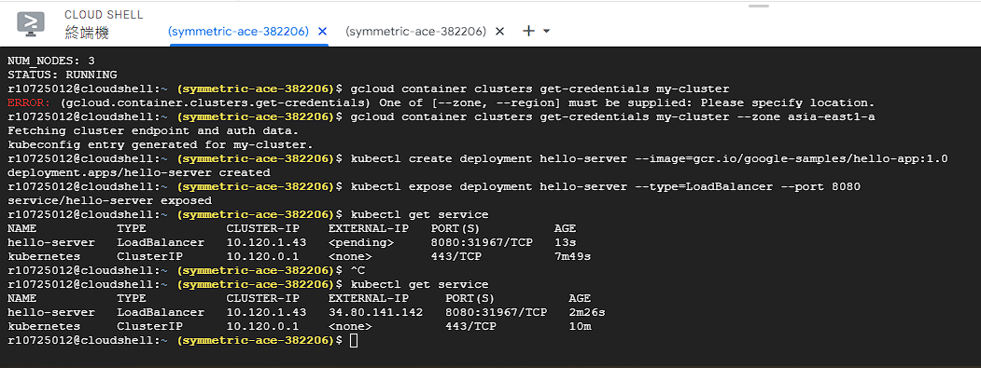

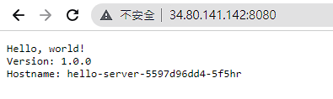

Task 4~3 : Creating Pods and Interacting with Pods

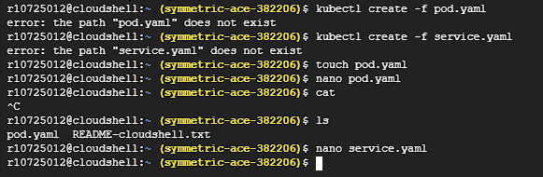

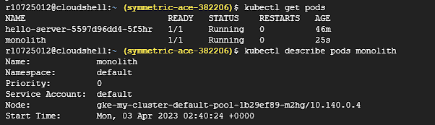

server

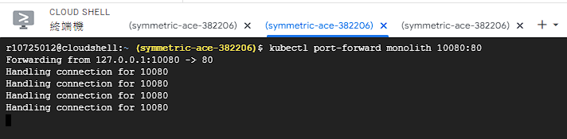

client

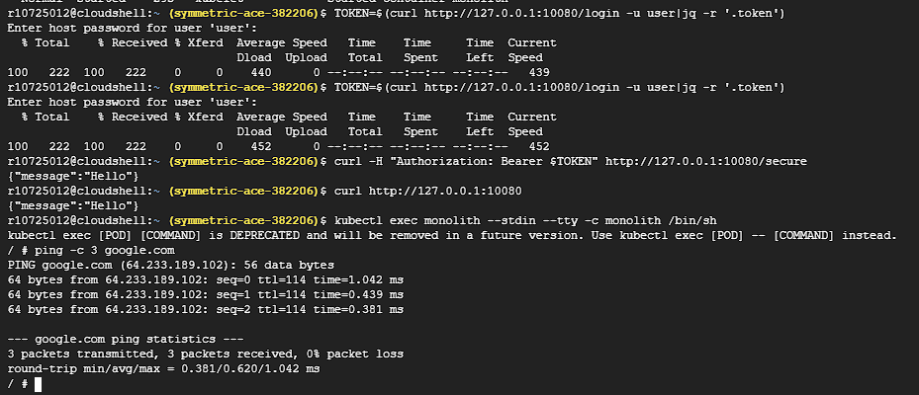

logs

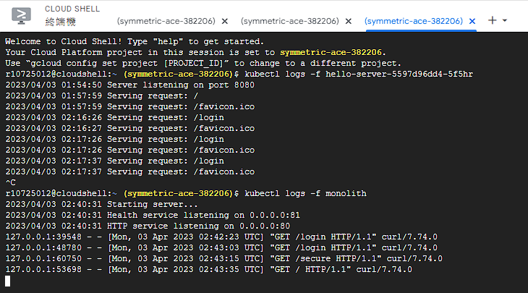

Task5: Create a Service

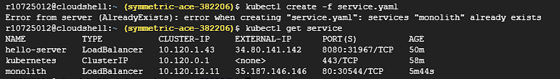

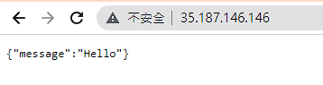

**Installing Anthos Service Mesh on GKE**

Pretask:

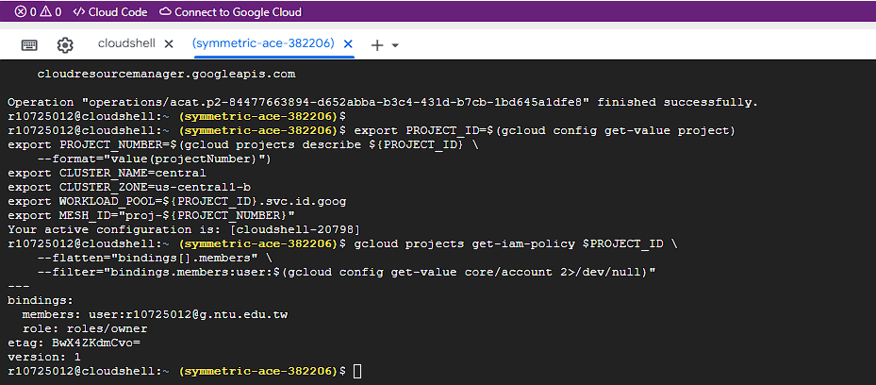

Task1: Set up your GKE cluster

Task2: Prepare to install Anthos Service Mesh

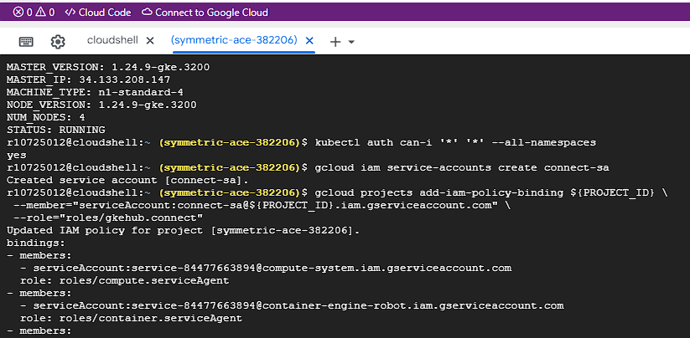

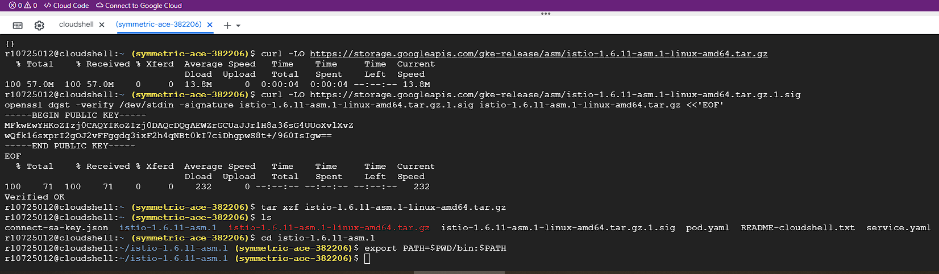

Task3: Preparing Resource Configuration Files

Task4: Install Anthos Service Mesh

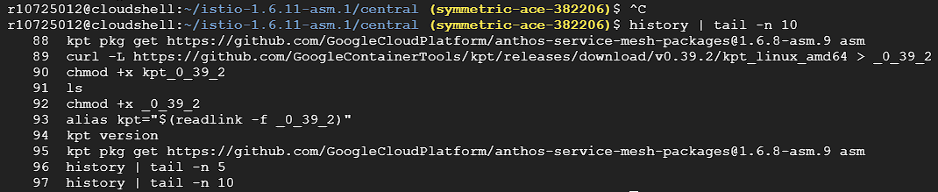

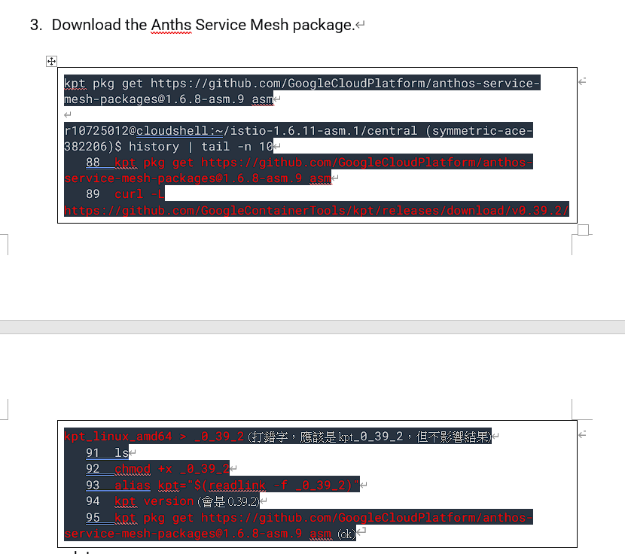

Kpt get 錯誤解法

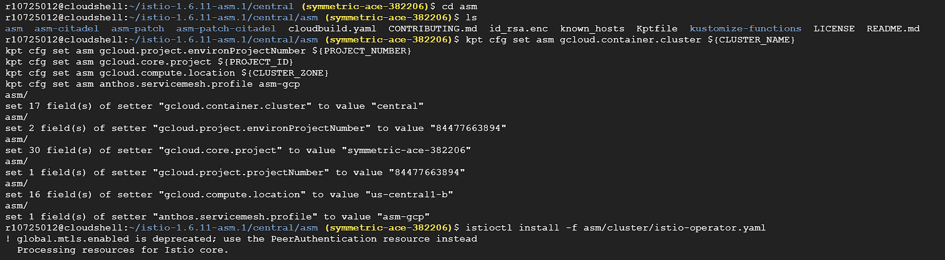

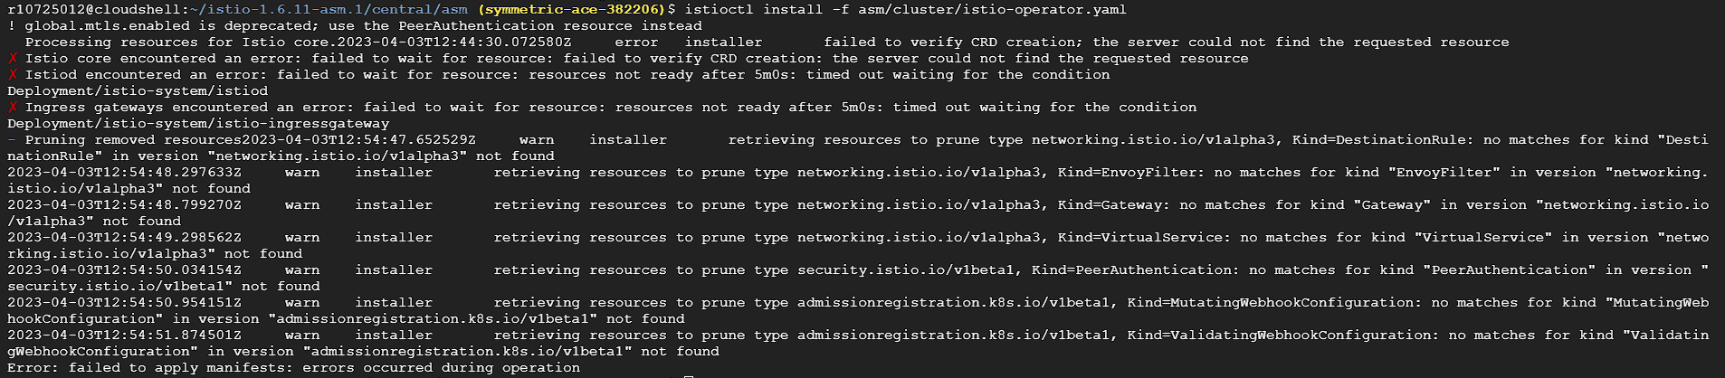

Clean-up gcloud container clusters delete central

**Implementing Cloud Run canary deployments with Git branches and Cloud Build**

Before Task:

Add run rules and enable APIs and set git configdata.

Your active configuration is: [cloudshell-21755]

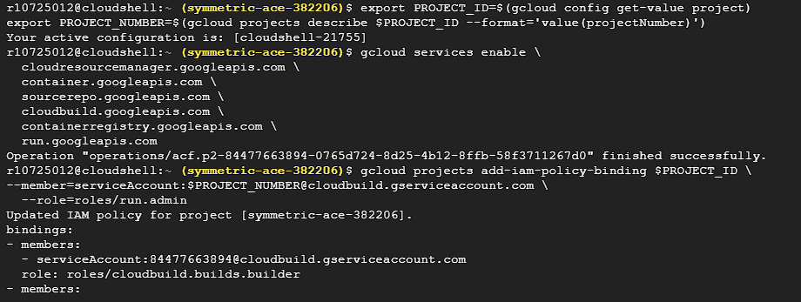

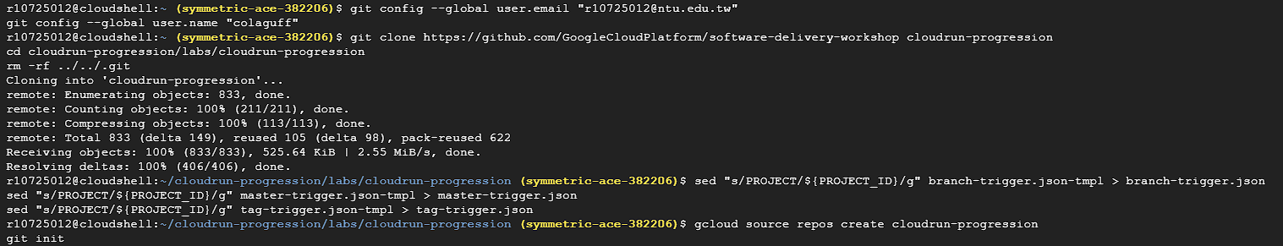

Task1: Creating your Cloud Run service

Task2: Enabling dynamic developer deployments

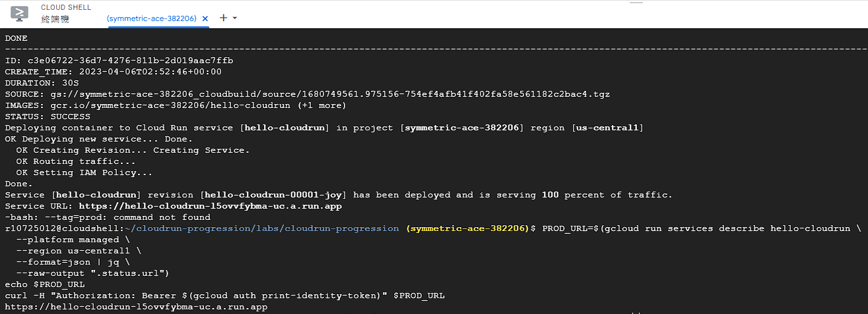

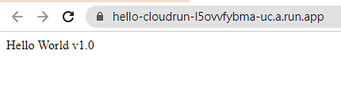

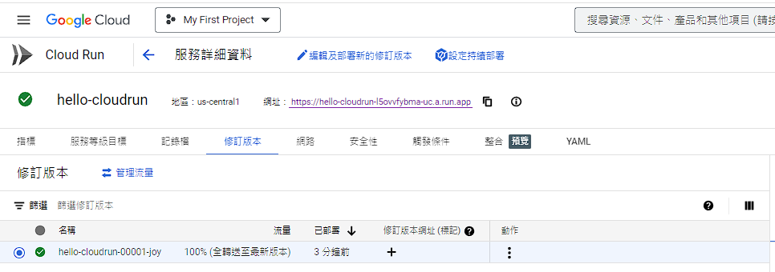

Tigger when build/deploy for any branch other than master

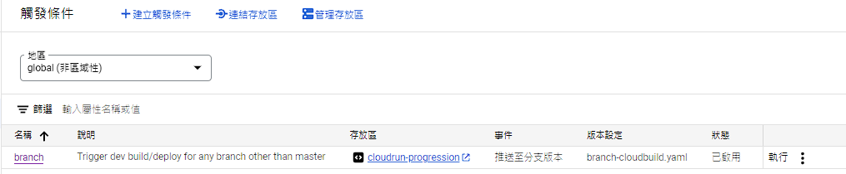

Edit v1.1 app.py

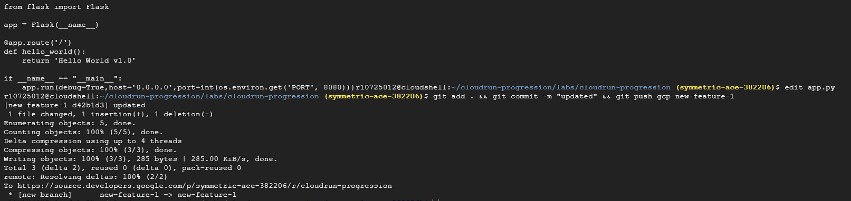

There is a new build

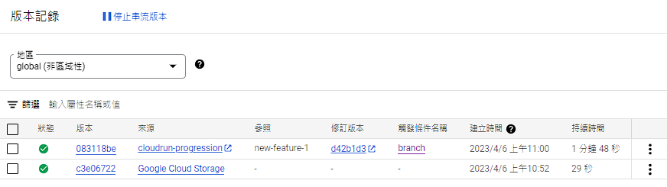

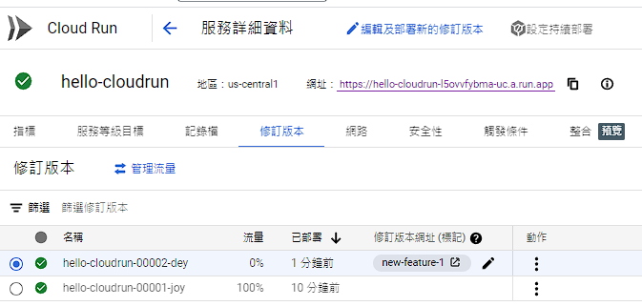

View the v1.1 web page

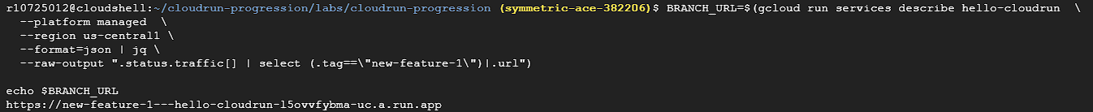

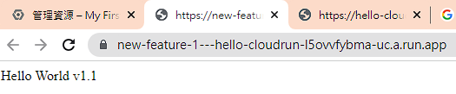

Task3: Automating canary testing

Merge branch to maser and git push gcp master.

See a third revision.

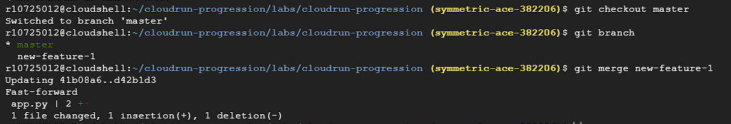

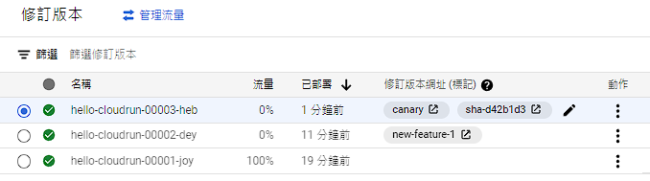

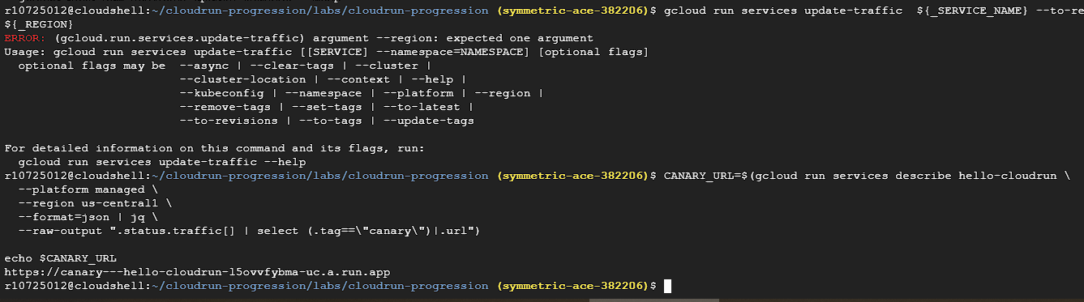

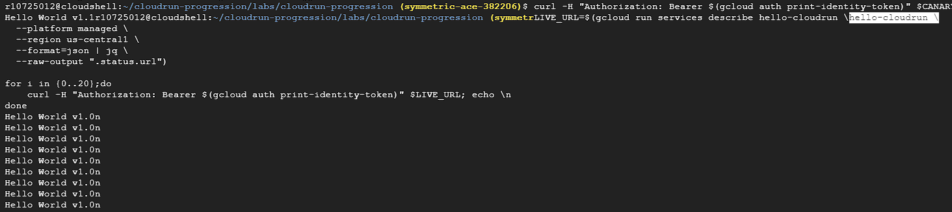

Task4: Releasing to production

set up the tag trigger, create a new tag and push to the remote repository

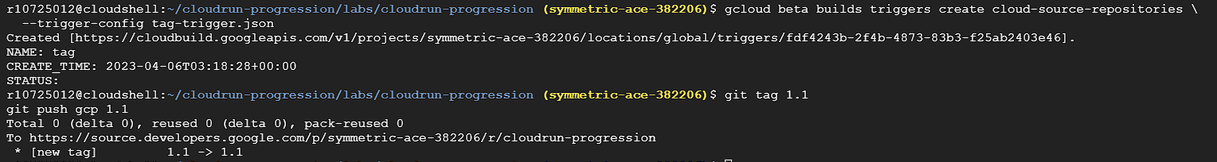

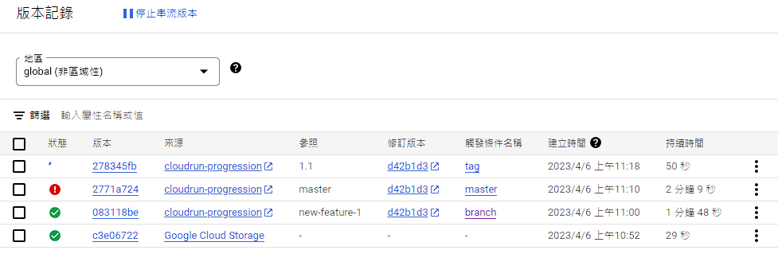

the revision is updated to indicate the prod tag and it is serving 100% of live traffic

